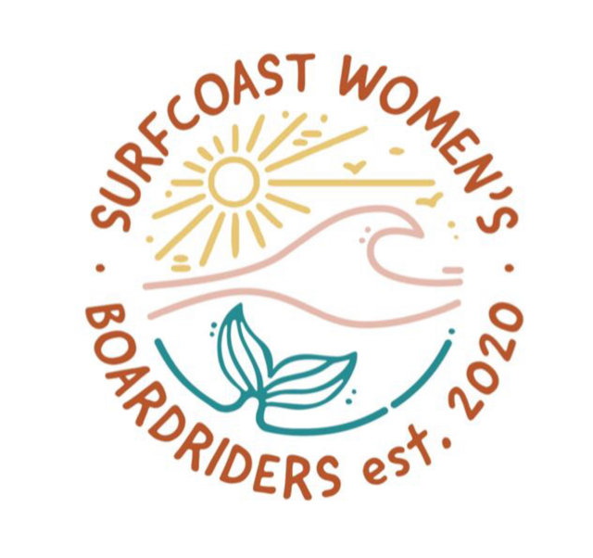

Event Waiver Form
2023 Season

Full Name: ___________________________________________________________

DOB:__________________________ Mobile:___________________________

Email:_____________________________________________________________________

Emergency Contact:__________________________________________________________

Relationship:______________________________ Phone: ___________________________

Board Size(s):_______________________________________________________________
Skill Level Please Circle):
Beginner 1: Absolute beginner; learning how to paddle, catch white wash and standing up.
Beginner 2: Can paddle, catch white wash and standing up comfortably, learning how to catch green waves.
Intermediate (Combined 1 & 2): Can comfortably catch green waves & paddle out the back, can do turns and drive down the line, perfecting the duck dive.
Advanced: Can surf in large (4-5ft) waves, practising manoeuvres (i.e. cutbacks, hang 10)

Existing Medical Conditions:_________________________________________________
Surf Coast Women’s Boardriders makes every effort to ensure a safe and fun event for everyone, by signing this waiver you agree to the following terms, conditions and rules for participating in our events.
Committee members, representatives, coaches, judges and all members:
- Recognise and abide by club rules.
- Respect others and equipment.
- Respect the privacy of others and do not give out personal details without permission.
- Conduct yourself in a proper manner, treat others with respect and be fair and considerate.
- Refrain from discrimination, abuse and bullying. We have zero tolerance for this behaviour.
- Respect the environment and take any rubbish with you or dispose of it appropriately and consciously.
- We encourage sustainable practices as much as possible and encourage members to do the same
- Be safety conscious and look out for fellow surfers and members, in and out of the water.
- Encourage and support fellow members.
- Bring any disputes or grievances up in a calm and appropriate manner with committee member(s) for resolution.
- Abide by surfing etiquette, awareness and safety during social and competition surfs – no drop ins, respect the line-up, communicate and refrain from discrimination or abuse.
- Surf Coast Women’s Boardriders takes no responsibility for any loss or damage to personal property
- Surf Coast Women’s Boardriders Club Membership offers basic insurance coverage only through Surfing Victoria; we take no responsibility in the event of injury, sickness or death.
- You agree to receive rescue assistance, first aid or medical assistance that the Club/Organiser deems necessary
- Accept that the event may be cancelled due to government-issued public health restrictions, weather conditions or other unforeseen circumstance
- You are medically and physically fit to participate in the Event.
- You agree to the use of pictures taken at events for use on social media and marketing for the Club.
- Enjoy yourself and keep FROTHING!

________________________________________
Member Signature & Date

